📄 CLIENT REQUIREMENTS DOCUMENT
Project: Student Record Management System

1️⃣ What the program is about
The program manages student records.
Each student has:
- an ID
- a name
- a course
- marks
The program allows:
- adding students
- viewing students
- saving data
- loading data
That’s it.

2️⃣ INPUT (very clear)
This program DOES take user input.
From the console, the user can:
- enter student details
- choose menu options
Example inputs:
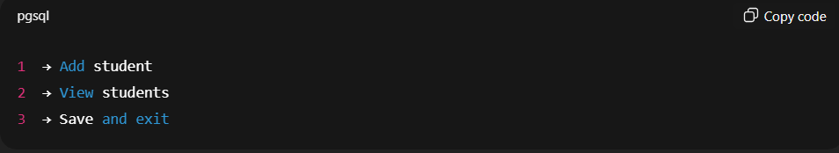
3️⃣ OUTPUT (very clear)
The program must:
- print menus
- print student records in a readable format
- print confirmation messages
Example output:
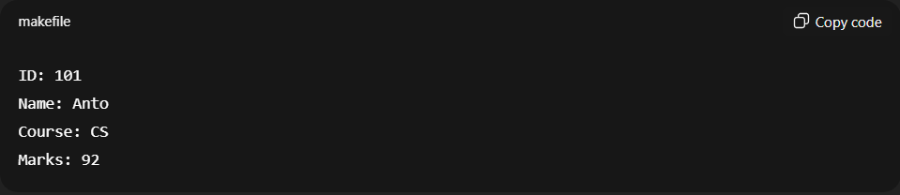
4️⃣ PROGRAM FLOW (step by step)
Your program must follow this flow:
- Start program
- Load existing students from file (if file exists)
- Show menu
- User chooses option
- Perform action
- Repeat menu until exit
- Save all students to file
- End program

5️⃣ DATA DESIGN REQUIREMENTS
Student representation
- Use a struct or class named Student
- It must store:
  - id
  - name
  - course
  - marks

Storage
- Store all students in:
  - vector<Student>

6️⃣ FILE HANDLING REQUIREMENTS
- All student data must be saved to one file
- File format can be simple text
- On program start:
  - if file exists → load students
  - if file doesn’t exist → start empty

7️⃣ DESIGN RULES (IMPORTANT)
❌ No global variables
❌ No hard-coded student data
❌ No spaghetti switch logic
❌ No mixing file code everywhere
✅ Separate:
- data model
- file handling
- menu logic

8️⃣ FILE STRUCTURE (minimum)
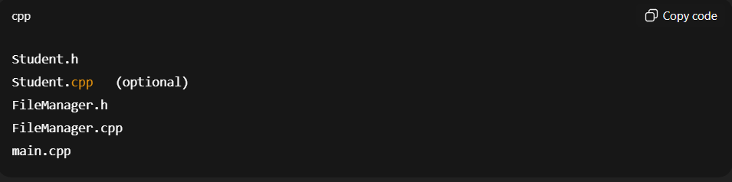
9️⃣ ACCEPTANCE CRITERIA (PASS / FAIL)
You PASS if:
- You can add multiple students
- Data persists after restart
- Code feels organized, not tangled
- You understand every line you wrote
You FAIL if:
- Data disappears on restart
- Everything is in main()
- You “just made it work” without understanding

10️⃣ CLIENT NOTE (important, read this)
This project is about structure, not speed.
If it feels slow and methodical, you’re doing it right.

